**SYSTEM’S INSTALLATION MANUAL**

Public vehicle complaint management system was a system created by a group of four students studying Bachelor of Science in Information Communication Technology. It is a mobile and web based system that manages public vehicle complaints received from complainants. Since public transport quality in the city needs discipline and traffic rules need strict implementation.

When public vehicle drivers do bad actions passengers and other civilians must not take this for granted and report or complain this to responsible authorities.

**Web Application**

* 1. **System Requirements**

|  |  |  |
| --- | --- | --- |
| **Operating System** | **Recommended Requirements** | **Minimum Requirements** |
| **Windows** | 2nd-generation Core i5 (2GHz+), 3rd/4th-generation Core i5 processor, or equivalent  Windows 7 or later | Core i3 or equivalent  Windows Vista or later |
| **Apple OS X** | Macbook Pro 2011 or newer, Macbook Air 2012 or newer;  OS X 10.9 or above | Macbook Pro 2010, Macbook Air 2011;  OS X 10.7 or above |
| **Linux** | Results will vary depending on OS distribution, driver support, and desktop environment |  |

|  |  |
| --- | --- |
| **Recommended GPU Requirements** | **Minimum GPU Requirements** |
| Intel HD4000 or comparable | Intel HD3000 or comparable |

* 1. **Installation**

1. Install Xampp by visiting <https://www.apachefriends.org/index.html>

* Click the download tab.

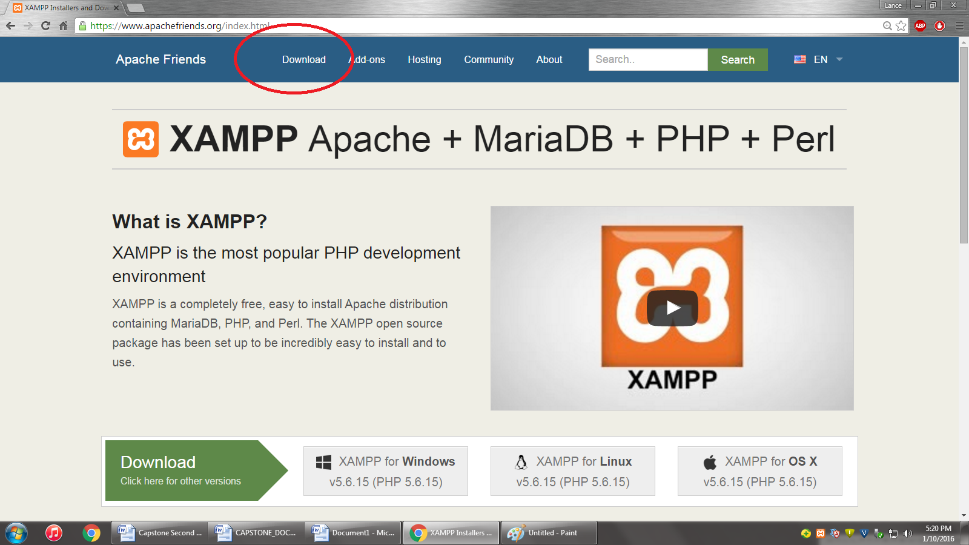

* Select which version that corresponds with your existing Operating System and click download.

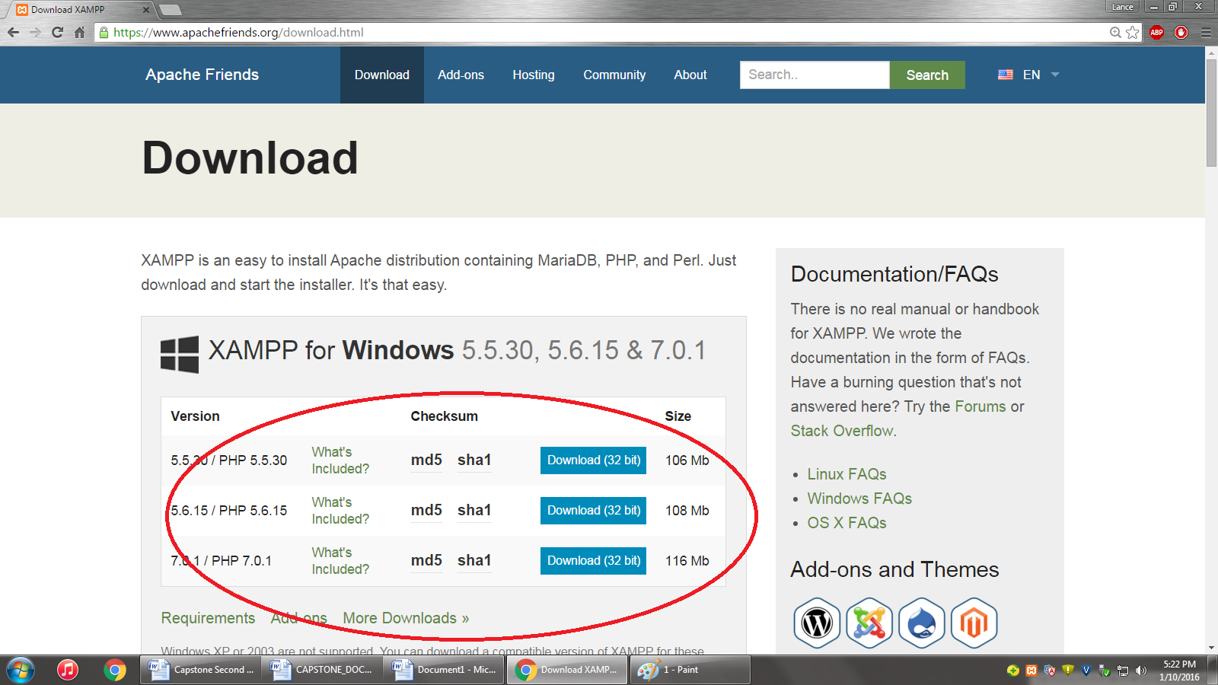

* The website will then redirect you to their download page

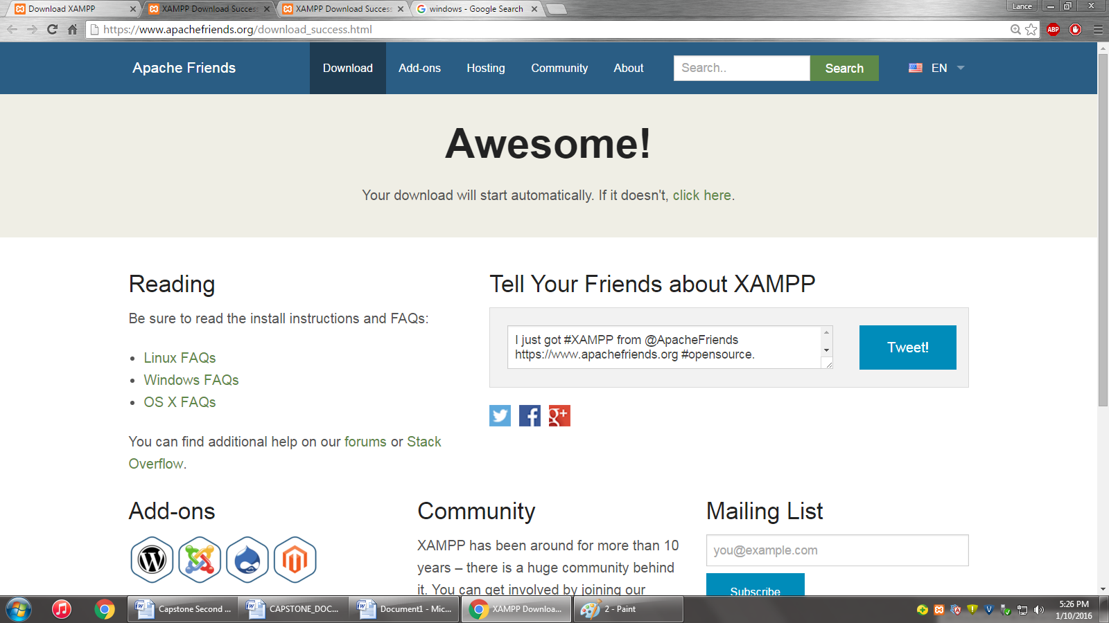

* Open up the “Local Disk” file under the “Computer” section and open the xampp folder.

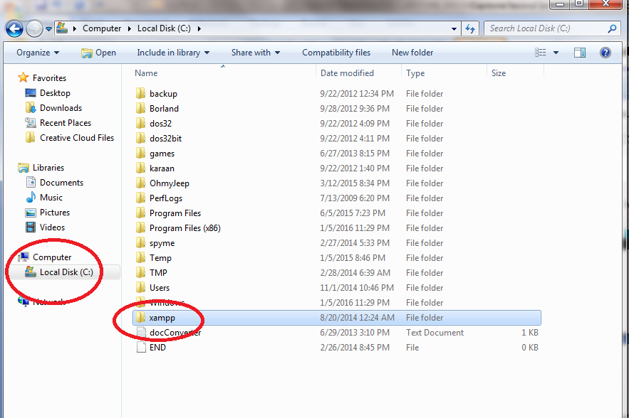

* Open up the xampp folder and click the Xampp-control application. It will then show the control panel which prompts the user to start the application. Click Start for both modules of Apache and Mysql.

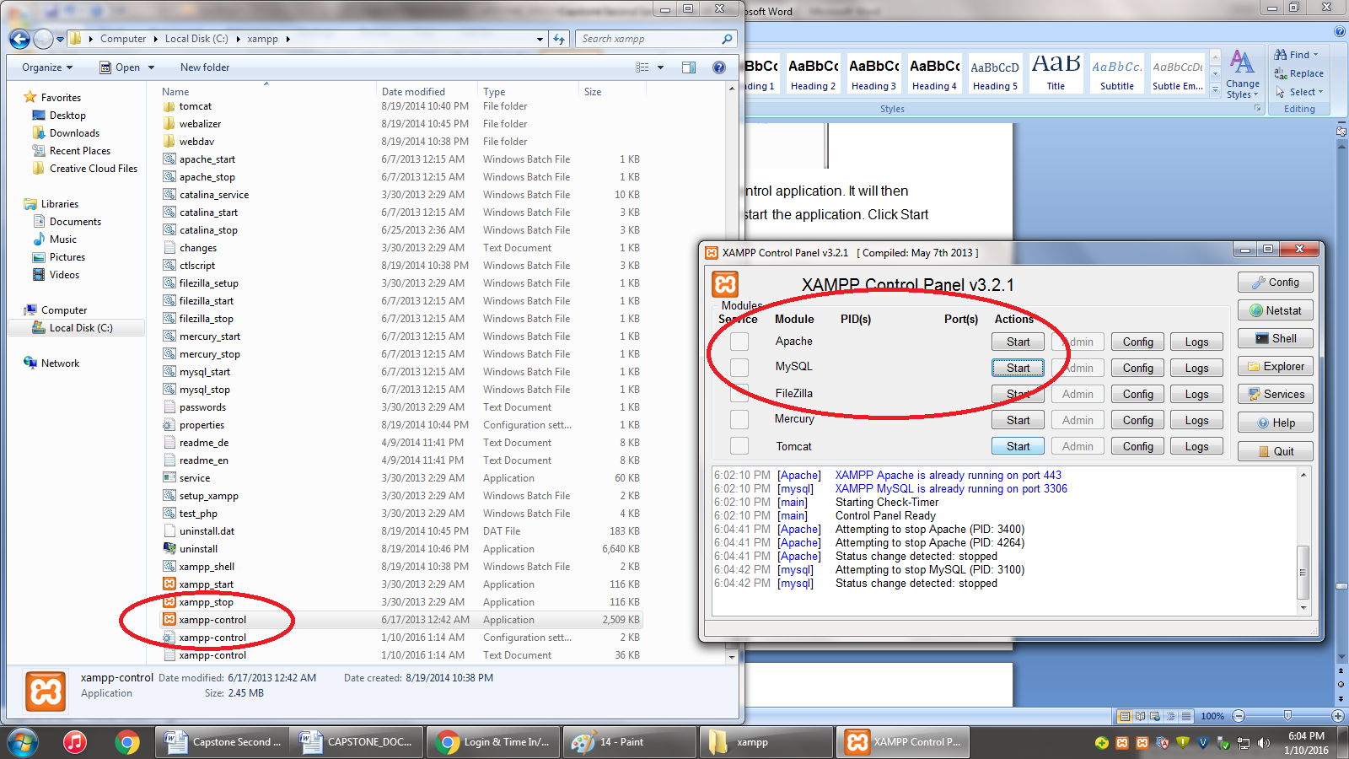

* Xampp comes with a folder called “htdocs”. The system will be copied and saved inside this folder for access.

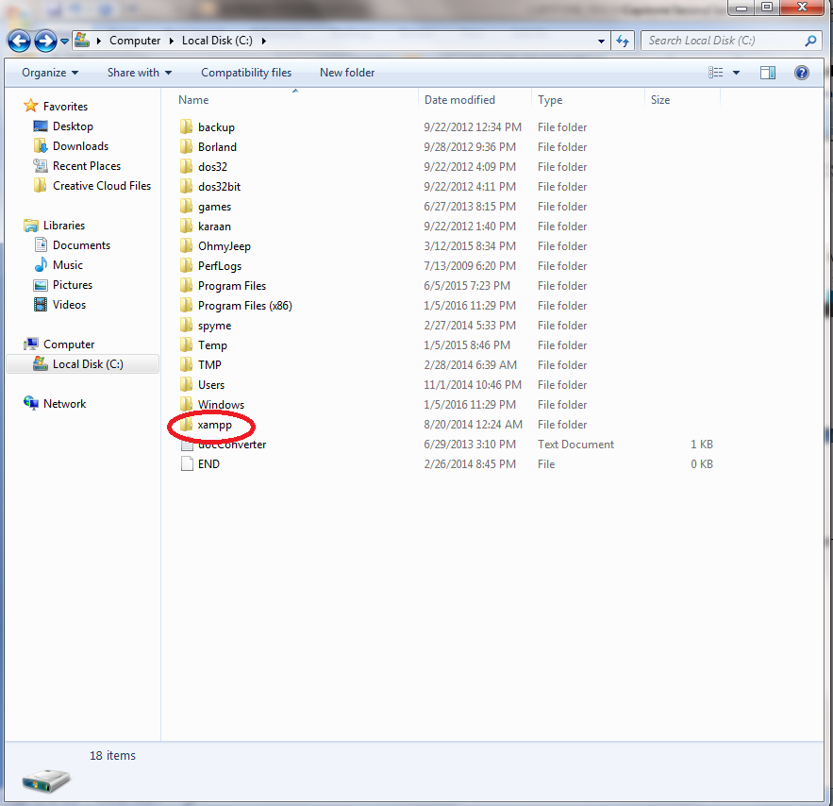

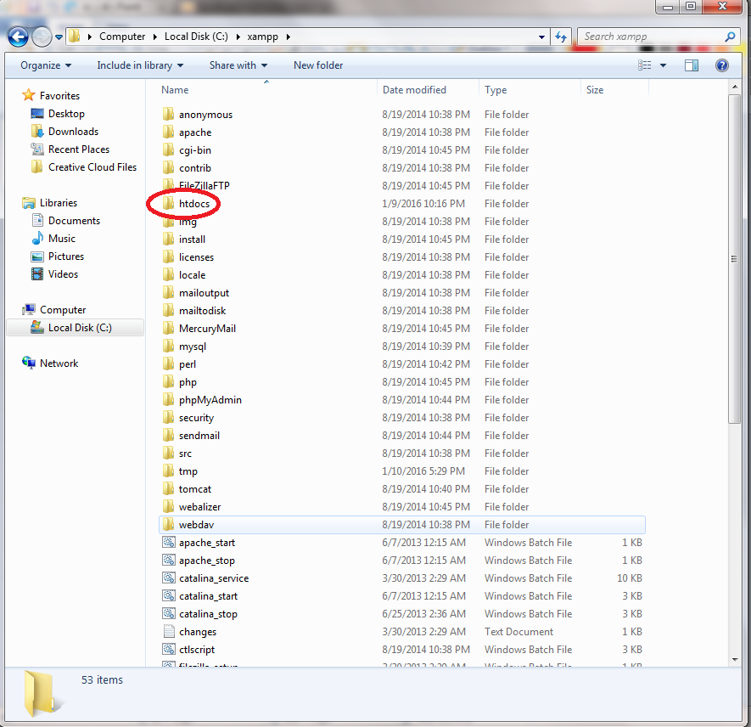

* Save the system folder inside “htdocs.”

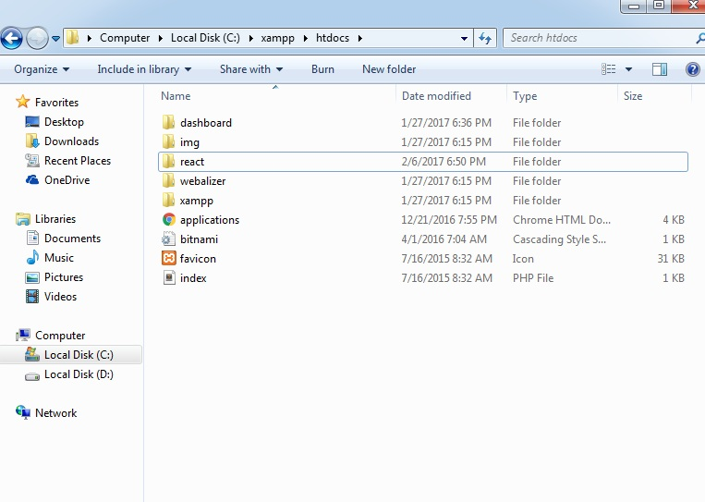

* Head onto your preferred browser and go enter on the search tab <http://localhost/phpmyadmin/>

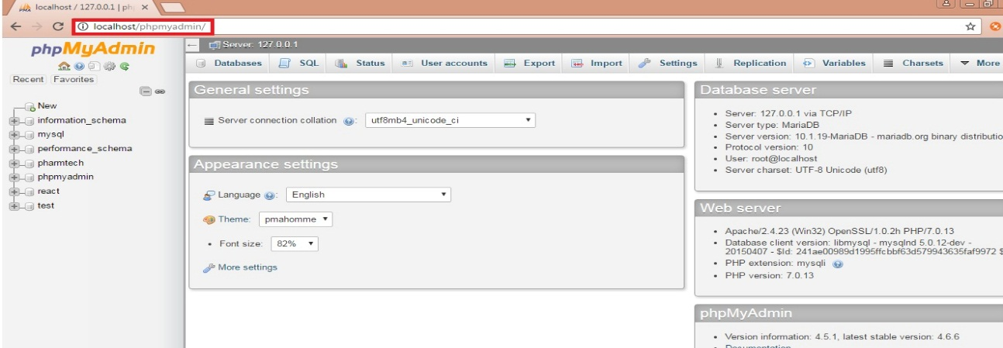

* Click the tab “Databases” or the sub menu named “New” on the left side.

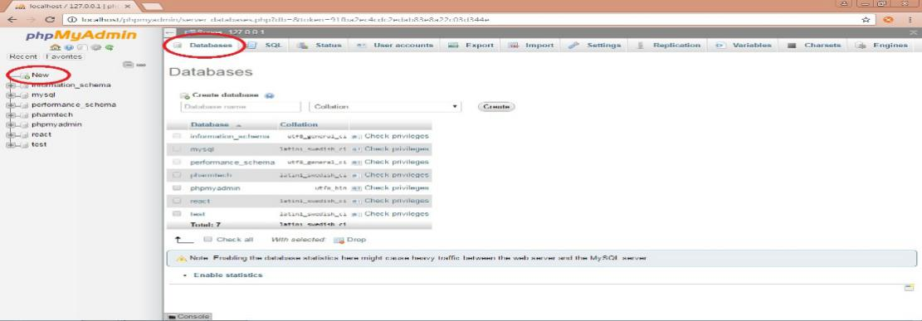

* The user will then be redirected to the Databases page which allows them to add the database given by the proponents.

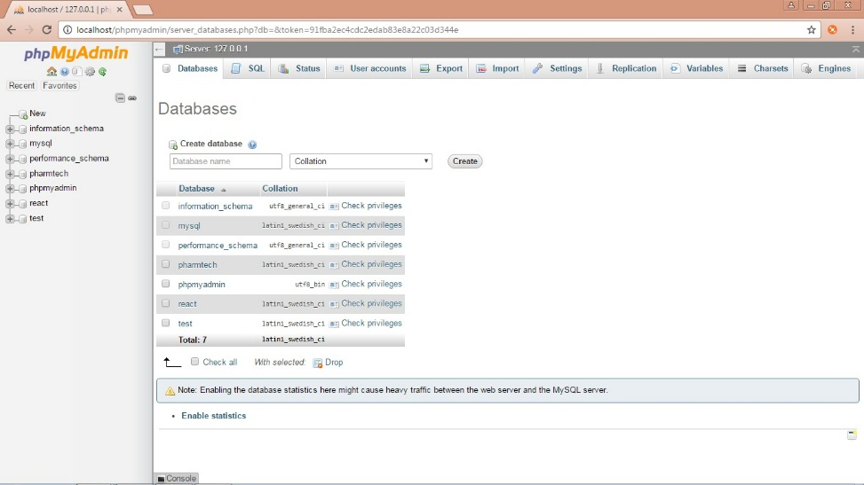

* Type in the name of the database. In this case, type in the name “react” and click create. The database will now be created.

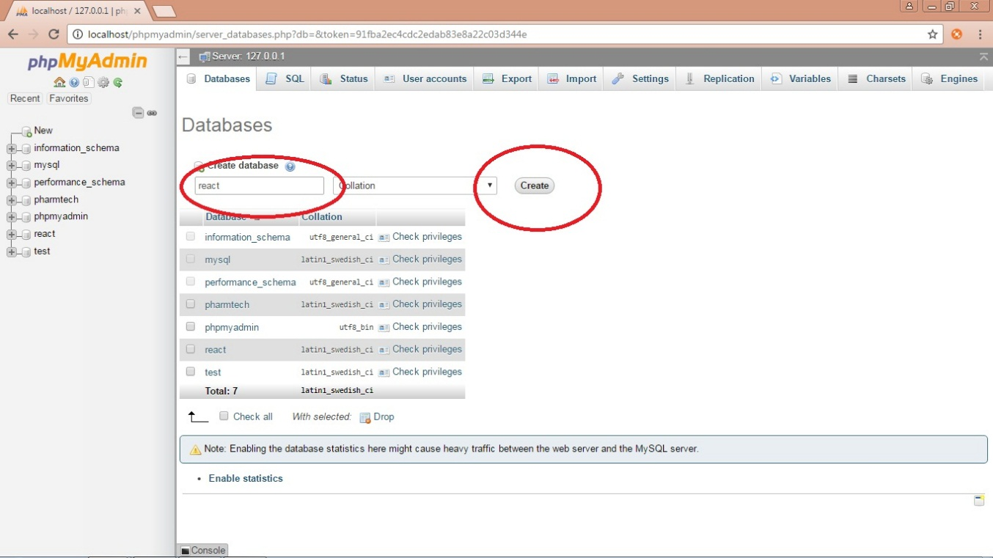

* Once the database is created, click the newly created database titled “react”. This will then redirect you to a new page, then click tab titled “Import” and click the button “choose file” and add the database presented by the proponents.

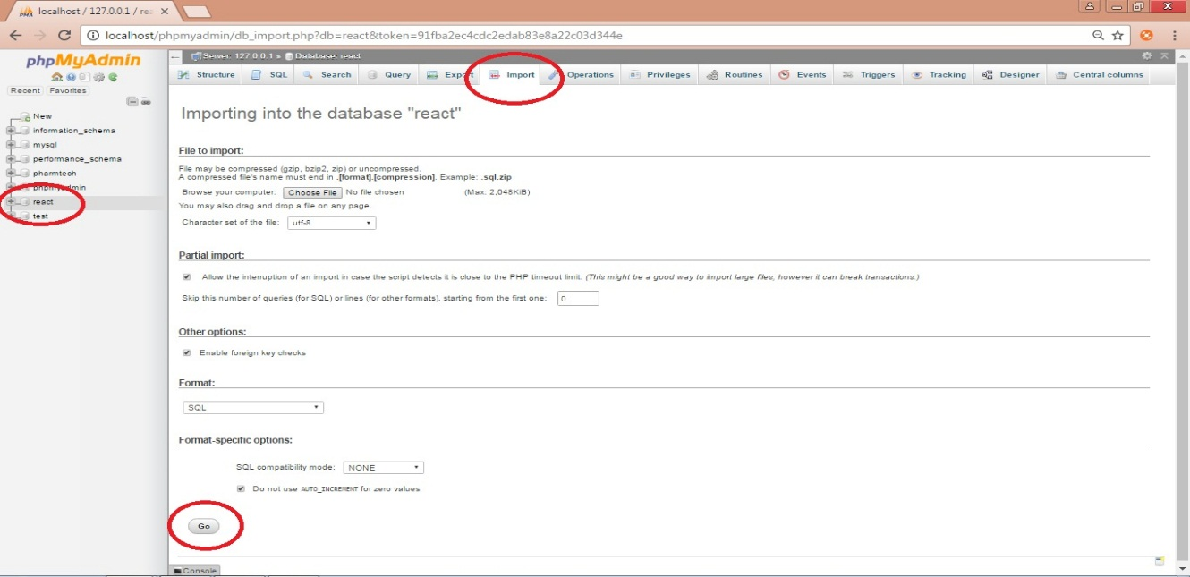

* Click the button “Go” then a confirmation will then appear stating the database was successfully created.

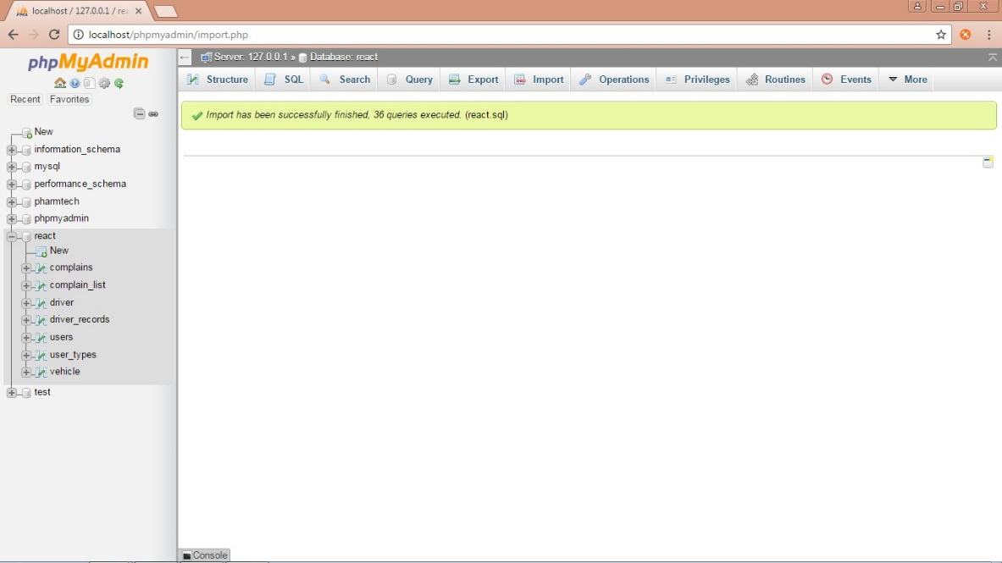

1. Setup Virtual Hosts

* Need to have XAMPP Installed.

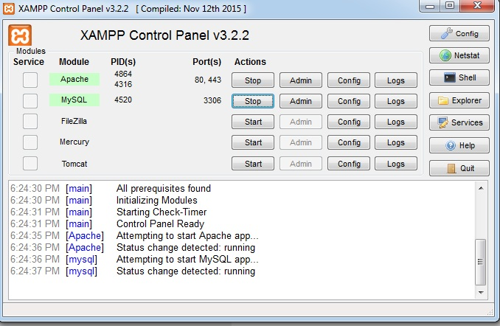

* Open up the Xampp control panel and stop Apache, MySQL.

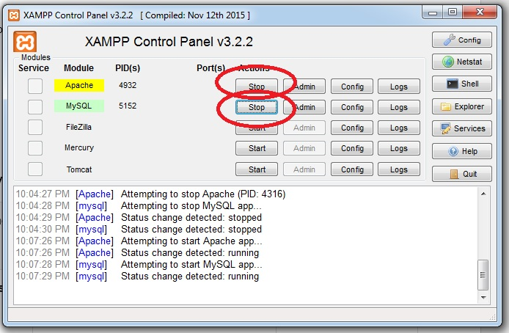

* Navigate to C:/xampp/apache/conf/extra and locate httpd-vhosts.

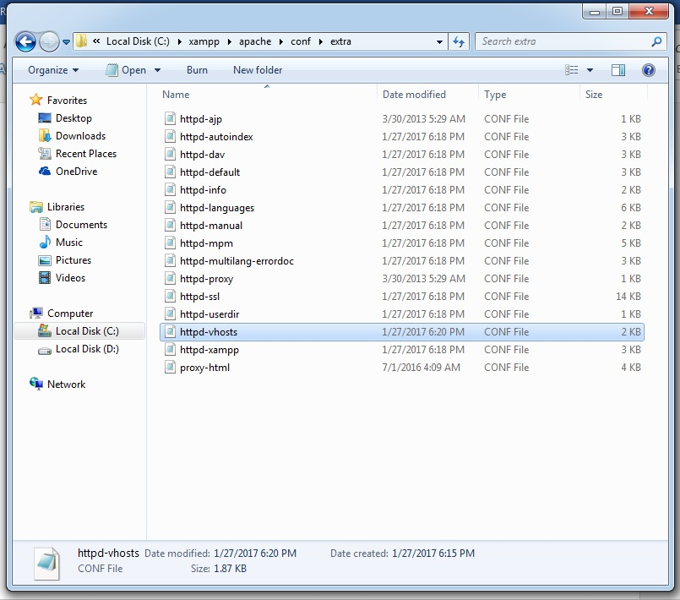

* At the very bottom of the file paste the following.

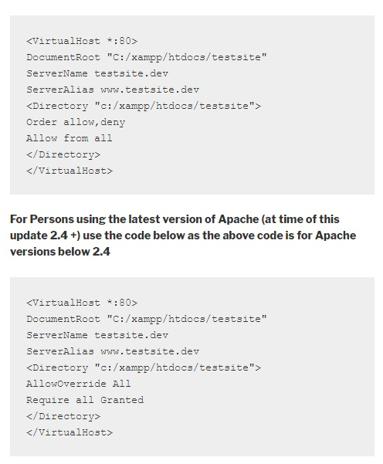

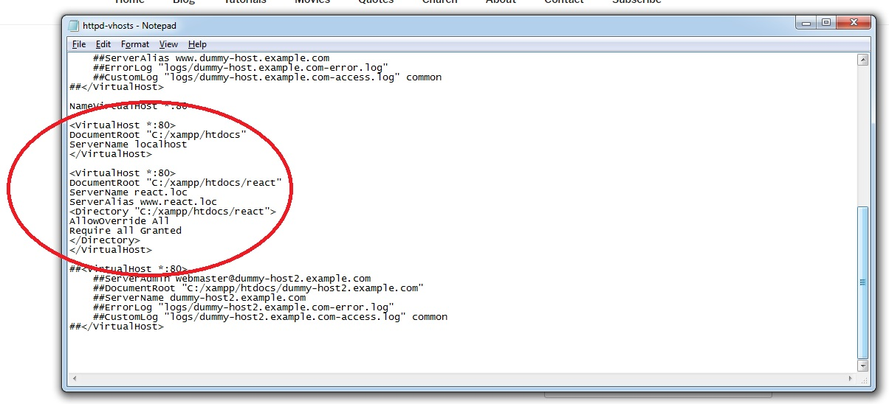

* Head over to Windows Hosts File, to edit the HOSTS. The file will be located at C:/Windows/System32/drivers/etc/hosts, where hosts is the file.

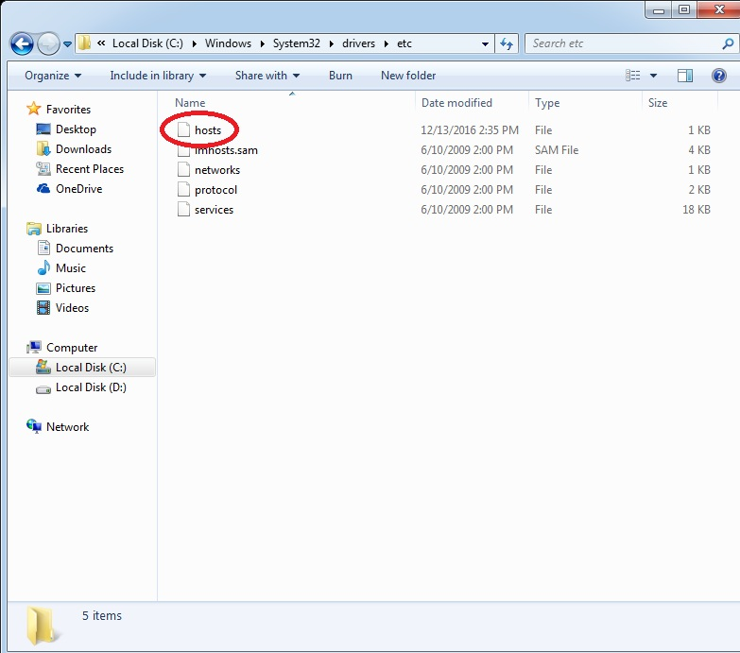

* Open the file with notepad.

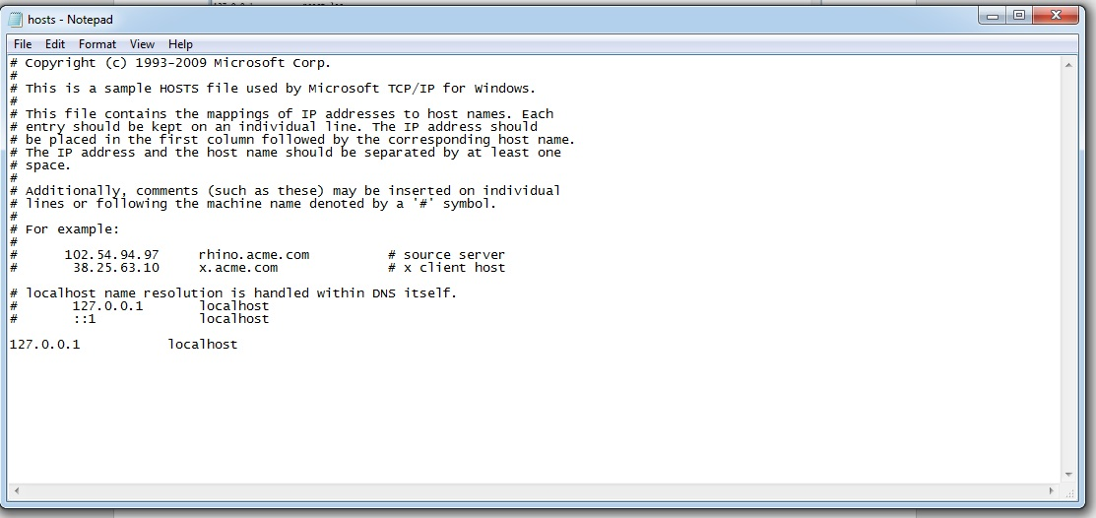

* Change the “localhost” to “react.loc”.

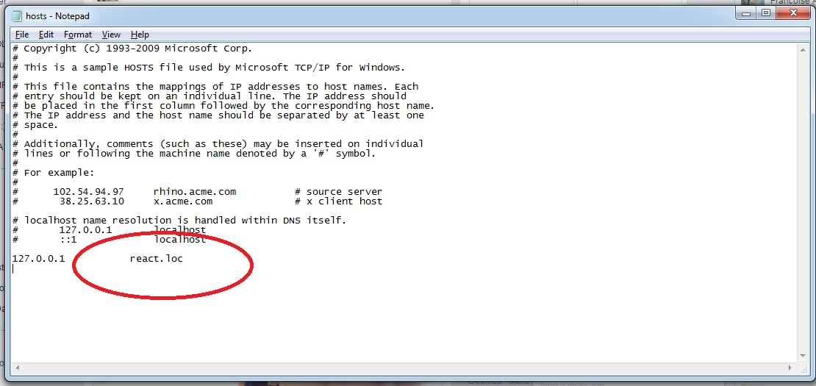

* Restart Apache and type in the URL react.loc to access the login page of our system.

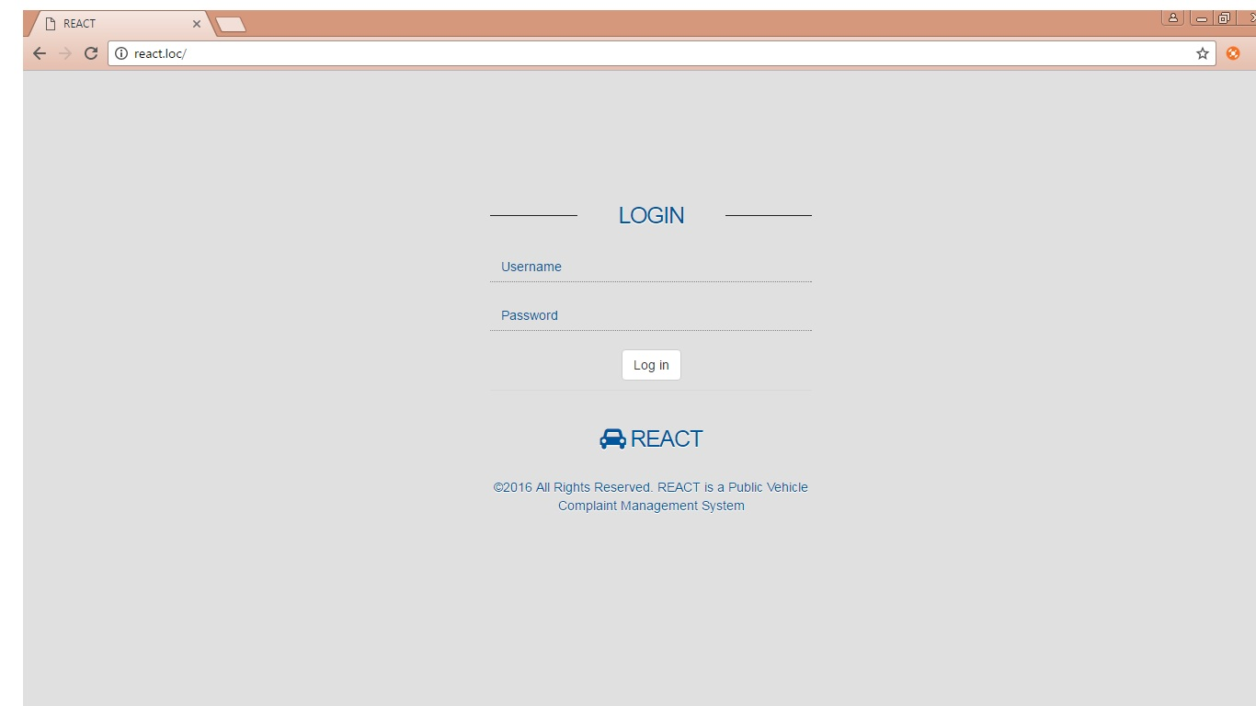

**Android Application**

* 1. **System Requirements**
  + Minimum requirement of Android Version is Ice cream Sandwich.
  + Must have high accuracy mode GPS.
  + Must have stable internet connection.

* 1. **Installation**
* Install the APK file of the application to access the home page.

